
Viewed by:
Yannick PETITBOIS
Tel.: +33 (0)2 99 27 92 92
E-mail: yannick.petitbois@iwedia.com

Written by:
Guy SCRUIGNEC
Tel.: +33 (0)2 99 27 92 92
E-mail: guy.scruignec@iwedia.com
IWEDIA

TDAL_OUTPUT Technical Specifications

V1.8

Approved by:
Thierry GARNIER
Tel.: +33 (0)2 99 27 92 92
E-mail: thierry.garnier@iwedia.com

SUMMARY
1 Reference documents 3
2 Documentation History 4
3 Introduction 5
4 Module Overview and Architecture 6
4.1 Definitions, Acronyms and Abbreviations 6
4.2 General Description 7
4.3 Architecture 7
4.3.1 Video Analogue Outputs 8
4.3.2 Video Digital Outputs 10
4.3.3 Audio Analogue Outputs 10
4.3.4 Audio Digital outputs 12
4.3.5 Audio Adjustment 12
4.3.6 RF Modulator 12
4.4 TDAL_OUTPUT API Function Description 14
4.4.1 Generic Interface 14
4.4.2 Video DENC Interface 14
4.4.3 Video HD DAC Interface 14
4.4.4 HDMI Interface 15
4.4.5 Video Digital Interface 15
4.4.6 Audio Analogue Interface 15
4.4.7 Audio SPDIF Interface 16
4.4.8 RF modulator interface 17
5 TDAL_OUTPUT API Specification 18
5.1 Type Specifications 18
5.1.1 Generic 18
5.1.2 Video DENC 18
5.1.3 Video HD DAC 18
5.1.4 HDMI 19
5.1.5 Video digital 19
5.1.6 Audio Analogue 19
5.1.7 RF modulator 19
5.2 TDAL_OUTPUT API Usage 19
5.3 TDAL_OUTPUT Macro/Define/Enum/Typedef/Structure Definitions 20
5.3.1 Define Definitions 20
5.3.2 Enum Definitions 20
5.3.3 Typedef Definitions 26
5.3.4 Structure Definitions 27
5.4 TDAL_OUTPUT API Functions 42
5.4.1 Generic Interface API 42
5.4.2 Video DENC Interface API 49
5.4.3 Video HD DAC Interface API 54
5.4.4 HDMI Interface API 56
5.4.5 Video Digital Interface API 58
5.4.6 Audio Analogue Interface API 60
5.4.7 Audio SPDIF Interface API 66
5.4.8 RF Modulator Interface API 69
5.4.9 Headphone Interface API 74

Reference documents
The following documents were used to write this specification:

Document | Version | Title
[IEC60958] | 2nd edition | IEC 60958-1 Digital Audio Interface – Part1 – General
[IEC61937] | 1st edition | IEC 61937-1 Digital Audio – Interface for non linear PCM encoded audio bitstreams applying IEC 60958 – Part1 - General
[ITU601] | Rev 5 (10/95) | ITU-R Recommendation BT.601-5 "Studio Encoding Parameters of Digital Television for Standard 4:3 and Wide-Screen 16:9 Aspect Ratios".
[ITU709] | Rev 5 (04/02) | ITU-R Recommendation BT.709-5 "Parameter values for the HDTV standards for production and international programme exchange".
[ITU1358] |  | ITU-R BT.1358 Studio parameters of 625 line and 525 line progressive scan television systems
[SMPTE240M] | 1999 | SMPTE 240M – 1999 - Television - Signal Parameters - 1125-Line High-Definition Production Systems
[SMPTE274M] | 2005 | SMPTE 274M - Television - 1920 x 1080 Image Sample Structure, Digital Representation and Digital Timing Reference Sequences for Multiple Picture Rates
[SMPTE295M] | 1997 | SMPTE 295M - Television - 1920 x 1080 50-Hz - Scanning and Interface
[SMPTE296M] | 2001 | SMPTE 296M - Television - 1280 x 720 Progressive Image Sample Structure - Analog and Digital Representation and Analog Interface
[EIA770.3] | Rev A (03/00/00) | EIA-770.3 - High Definition TV Analog Component Video Interface

Documentation History

History
Version | Date | Nature
1.0 | 09/06/06 | GS: First version of TDAL_OUTPUT
1.1 | 05/07/06 | GS:  - In TDAL_OUTPUT_VideoDencFormatSet(-), a format mask is given as input parameter.  - Add TDAL_OUTPUT_APIRevisionGet(-) and TDAL_OUTPUT_PlatformRevisionGet(-) functions.
1.2 | 23/10/07 | YP : Update for Audio_Description Feature
1.3 | 05/09/08 | YP : Extend Digital Audio Mode
1.4 | 07/10/08 | YP : Add Audio Adjust and Audio Delay
1.5 | 10/10/08 | YP : Add explanation on Audio Adjustment
1.6 | 13/10/08 | GS: Add digital video ouput interface
1.7 | 18/08/09 | GS: Add headphone hotplug detection interface

Introduction
The purpose of this document is to specify the interface and to describe the internal design of the Thin Driver Adaptation Layer Output [TDAL_OUTPUT]. The aim of this module is to provide a complete interface between middlewares and the video output stage low level driver of a set-top-box.

Module Overview and Architecture

Definitions, Acronyms and Abbreviations
CVBS: | Composite video
DAC: | Digital to Analog Converter
DENC: | Digital Encoder
DVI: | Digital Visual Interface
HD: | High Definition
HDMI: | High Definition Multimedia Interface
LFE: | Low Frequency Effect
NTSC: | National Television System Comitee
PAL: | Phase Alternative Lines
PCM: | Pulse Code Modulation
RF: | Radio Frequency
RGB: | Red-Green-Blue
SD: | Standard Definition
SECAM: | “SÉquentiel Couleur À Mémoire”
SMPTE | Society of Motion Picture & Television Engineers
SPDIF: | Sony Philips Digital Interface Format
S-Video: | Separate video with two signals (brightness and colour)
UHF: | Ultra High Frequency. Band of radiofrequencies from 300 MHz to 3 GHz
VHF: | Very High Frequency. Band of radiofrequencies from 30 MHz et 300 MHz
YC: | Another name for S-Video
YCbCr | YCbCr is a family of colour spaces used in video systems. Y is the luma component and Cb and Cr the chroma blue and red components.
YUV: | Luminance and colour difference signal in component video system

General Description
The main job of the TDAL_OUTPUT is to control audio/video output stage of a set-top-box.
TDAL_OUTPUT is divided in several sub-parts in order to control different kinds of output:
- Video Analogue (DENC, HD DAC)
- Video Digital (HDMI, video digital bus)
- Audio analogue
- Audio digital (SPDIF)
- RF modulator

Architecture
The figure below shows the relation between the client output module and the low level drivers:
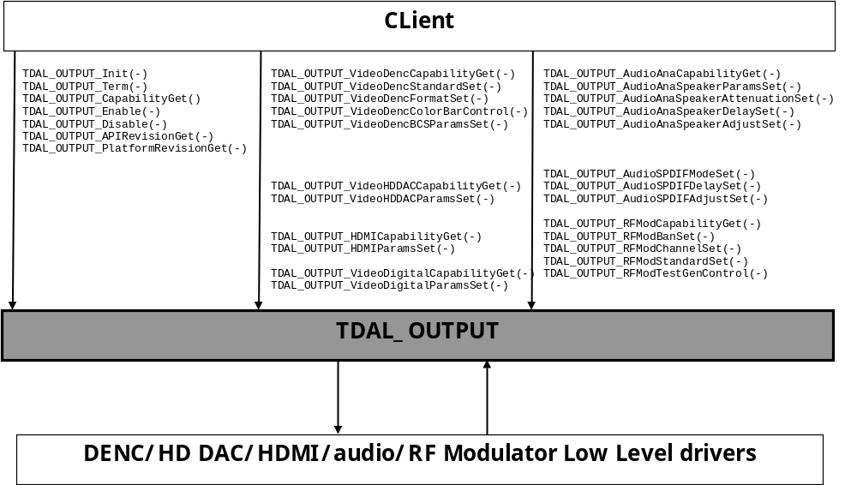

Video Analogue Outputs
The video analogue Outputs is the last stage of video processing.
It consists of grouping of the following hardware modules:
- The DENC module converts the digital video uncompressed stream coming from one or several Blenders into a standard analogue video signals.
- The HD DAC module converts the digital video uncompressed stream coming from one or several Blenders into a standard high definition analogue video signals.
There can be more than one video analogue Output stage in a set-top-box depending on dual TV capability.
The following diagram shows the different module that an analogue video output stage can have:
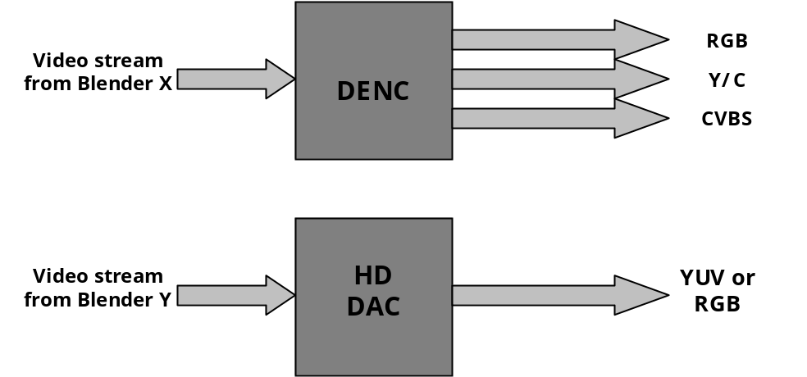
Various configurations are possible depending of use cases. Here are some use case examples:
- Single video decode with single video analogue output DENC stage:
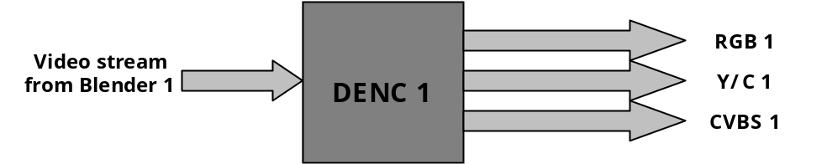
- Single video decode with video analogue output DENC and HD DAC stage:
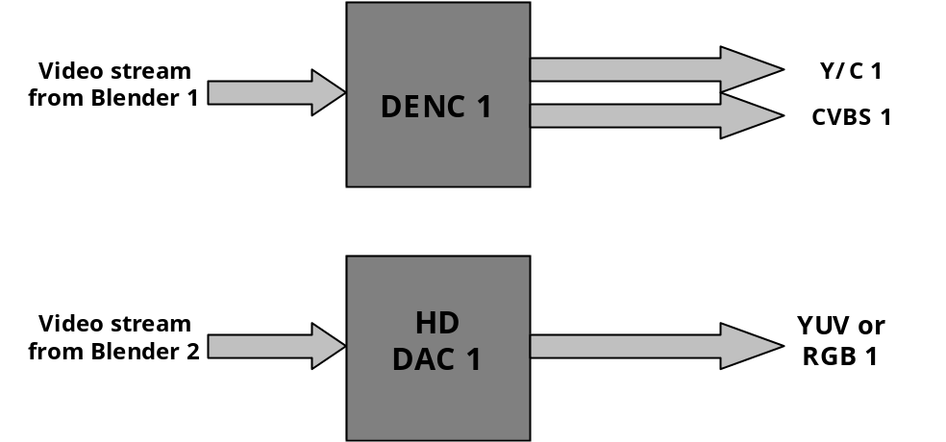
- Dual decode with single video analogue output DENC stage :
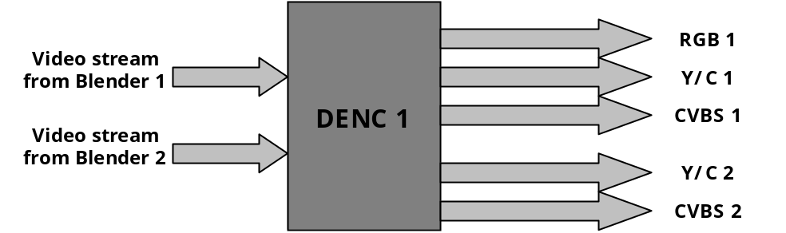
- Dual decode with dual video analogue DENC stages:
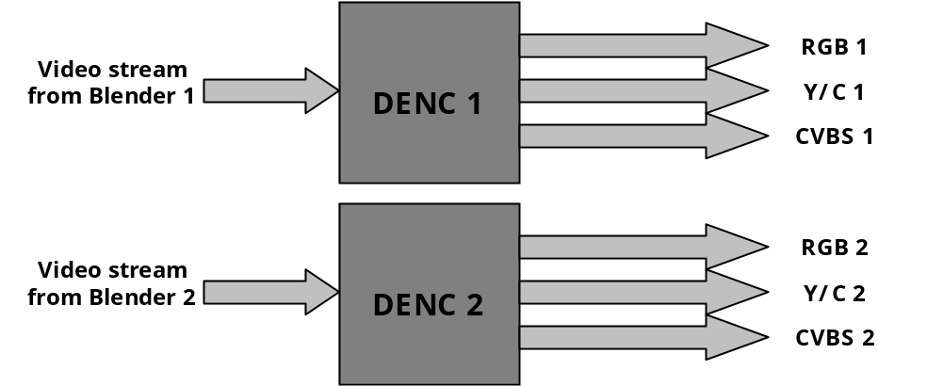

Video Digital Outputs
The video digital Outputs is the last stage of video processing.
It consists of grouping of the following hardware modules:
- The HDMI/DVI module which is directly connected to a blender.
- The digital video output which is directly connected to a blender.
There can be more than one video digital Output stage in a set-top-box depending on dual TV capability.

Audio Analogue Outputs
The audio analogue output is responsible for converting the digital PCM stream coming from an audio decoder into a set of audio signals.
TDAL_OUTPUT audio analogue part is capable of supporting 8.1 speaker system as shown in the following diagram:
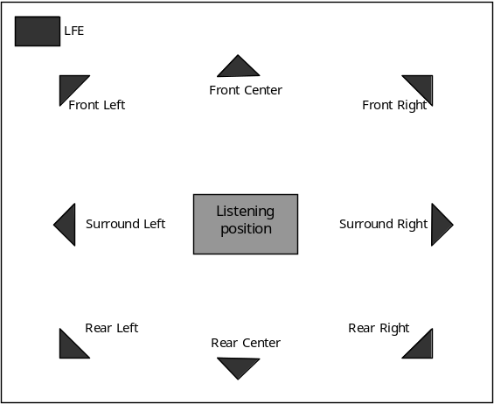
Various configurations are possible depending of use cases. Here are some use case examples:
- 2.0 speaker system
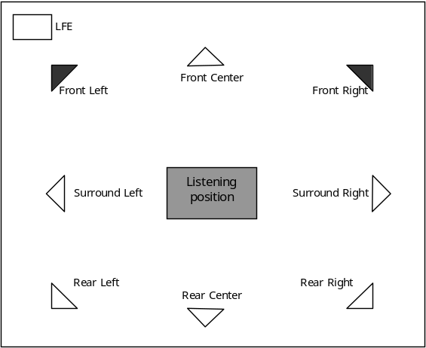
- 5.1 speaker system
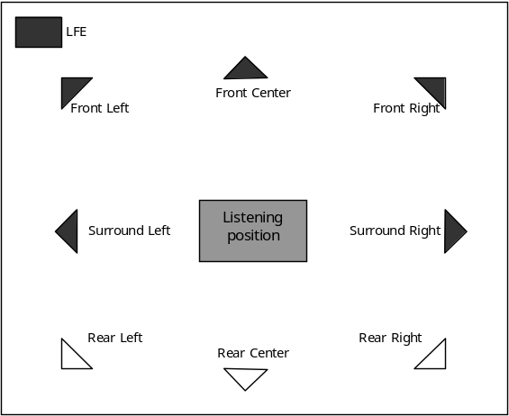
- 6.1 speaker system
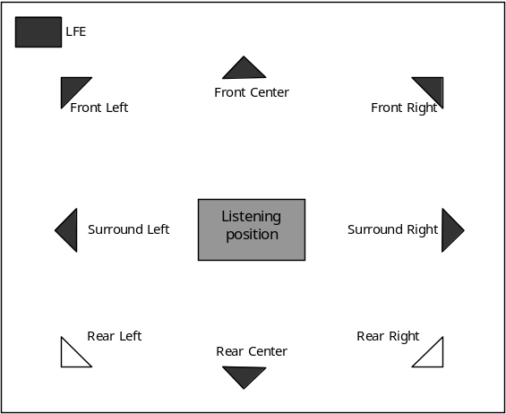
- 7.1 speaker system
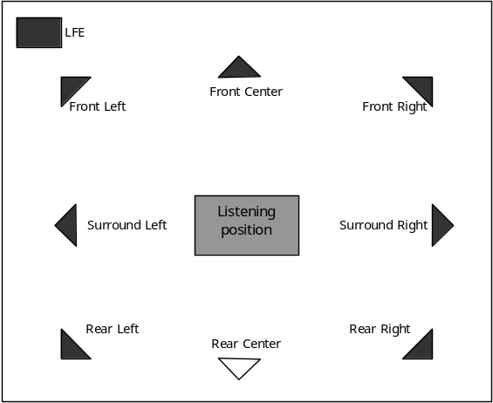

Audio Digital outputs
The SPDIF audio output is responsible for reformatting digital audio stream coming from the audio decoder. TDAL_OUTPUT supports [IEC61937] (the compressed bitstream is transmitted on the digital output and can be decoded by an external decoder) and [IEC60958] (the output are PCM data, only the left and right channels are transmitted).
The SPDIF connector type (co-axial or optical) is not in the scope of TDAL_OUTPUT.

Audio Adjustment
Depending on incoming audio stream type, initial volume could differ from PCM track to Bitstream track. It is the reason why volume adjustment could be requested by user.
Please check example below:
Stereo PCM (-20dB)
+/-6dB
Audio Input
Data (-31dB)
Audio Output Mode
Stereo PCM (-20dB)
+/- 6dB
Data (-31dB)
Data preferred
Stereo only
Adjust (-11 +/-6 dB)
Adjust (+/- 6 dB)
Downmix (+11 dB)
-31 dB
-31 dB
-20 dB
-20 dB
Adjust not possible

RF Modulator
The RF modulator output is responsible for re-modulating of CVBS video signal and analogue right/left audio signals into UHF/VHF modulated signal.

TDAL_OUTPUT API Function Description

Generic Interface
The generic interface allows clients to control the TDAL_OUTPUT module.
This interface is used with the following functions:
- TDAL_OUTPUT_Init(-) in order to initialize the TDAL_OUTPUT module.
- TDAL_OUTPUT_Term(-) in order to terminate the TDAL_OUTPUT module.
- TDAL_OUTPUT_CapabilityGet(-) in order to get the capabilities of the current implementation of TDAL_OUTPUT module.
- TDAL_OUTPUT_Enable(-) in order to enable a specific output.
- TDAL_OUTPUT_Disable(-) in order to disable a specific output.
- TDAL_OUTPUT_RevisionGet(-) in order to retrieve the revision of TDAL_OUTPUT.

Video DENC Interface
The video DENC interface part of the TDAL_OUTPUT API allows clients to control DENC modules.
This interface is used with the following functions:
- TDAL_OUTPUT_VideoDencCapabilityGet(-) in order to get the capabilities of a specific DENC output.
- TDAL_OUTPUT_VideoDencStandardSet(-) in order to set a video standard (PAL, SECAM, NTSC, …) of a specific DENC output.
- TDAL_OUTPUT_VideoDencFormatSet(-) in order to set a video format (CVBS, YC, RGB, …) of a specific DENC output.
- TDAL_OUTPUT_VideoDencColorBarControl(-) in order to control the colour bar test pattern of a specific DENC output.
- TDAL_OUTPUT_VideoDencBCSParamsSet(-) in order to set the video brightness/contrast/saturation of a specific DENC output.

Video HD DAC Interface
The video HD DAC interface part of the TDAL_OUTPUT API allows clients to control HD DAC output.
This interface is used with the following functions:
- TDAL_OUTPUT_VideoHDDACCapabilityGet(-) in order to get the capabilities of a specific HD DAC output.
- TDAL_OUTPUT_VideoHDDACParamsSet(-) in order to set the parameters (colour space, HD standard, format RGB or YCbCr, …) of a specific HD DAC.

HDMI Interface
The HDMI interface part of the TDAL_OUTPUT API allows clients to control HDMI output.
This interface is used with the following functions:
- TDAL_OUTPUT_HDMICapabilityGet(-) in order to get the capabilities of a specific HDMI output.
- TDAL_OUTPUT_HDMIParamsSet(-) in order the set the parameters (format RGB888, YCbCr422 or YCbCr444, HD standard and audio compressed format or not compressed mode) of a specific HDMI output.

Video Digital Interface
The HDMI interface part of the TDAL_OUTPUT API allows clients to control HDMI output.
This interface is used with the following functions:
- TDAL_OUTPUT_VideoDigitalCapabilityGet(-) in order to get the capabilities of a specific video digital output.
- TDAL_OUTPUT_VideoDigitalParamsSet(-) in order the set the parameters (format RGB888, YCbCr444, HD standard) of a specific video digital output.

Audio Analogue Interface
The audio analogue interface part of the TDAL_OUTPUT API allows clients to control audio analogue signals.
This interface is used with the following functions:
- TDAL_OUTPUT_AudioAnaCapabilityGet(-) in order to get the capabilities of a specific audio analogue output.
- TDAL_OUTPUT_AudioAnaSpeakerParamsSet(-) in order to set the speaker parameters (type large, small or none) of a specific audio analogue output.
- TDAL_OUTPUT_AudioAnaSpeakerAttenuationSet(-) in order to set the speaker volume attenuation of a specific audio analogue output.
- TDAL_OUTPUT_AudioAnaSpeakerAttenuationGet(-) in order to get the speaker volume attenuation of a specific audio analogue output.
- TDAL_OUTPUT_AudioAnaSpeakerDelaySet(-) in order to set the speaker delays of a specific audio analogue output.
- TDAL_OUTPUT_AudioAnaSpeakerAdjustSet(-) in order to set the speaker audio volume adjustment of a specific audio analogue output.

Audio SPDIF Interface
The audio SPDIF interface part of the TDAL_OUTPUT API allows clients to control audio SPDIF output.
This interface is used with the following function:
- TDAL_OUTPUT_AudioSPDIFModeSet(-) in order to set the mode (compressed format or not compressed) of a specific audio SPDIF output.
- TDAL_OUTPUT_AudioSPDIFAdjustSet(-) in order to set the volume adjustment of a specific audio SPDIF output.
- TDAL_OUTPUT_AudioSPDIFDelaySet(-) in order to set the audio delay of a specific audio SPDIF output.

RF modulator interface
The RF modulator interface part of the TDAL_OUTPUT API allows client to control RF modulator output.
This interface is used with the following functions:
- TDAL_OUTPUT_RFModCapabilityGet(-) in order to get the capabilities of a specific RF modulator output.
- TDAL_OUTPUT_RFModBandSet(-) in order to set the band (UHF or VHF) of a specific RF modulator output.
- TDAL_OUTPUT_RFModChannelSet(-) in order to set the channel of a specific RF modulator output.
- TDAL_OUTPUT_RFModStandardSet(-) in order to set the standard (PAL, SECAM, NTSC) of a specific RF modulator output.
- TDAL_OUTPUT_RFModTestGenControl(-) in order to generate the test pattern signal of a specific RF modulator output.

TDAL_OUTPUT API Specification

Type Specifications

Generic
tTDAL_OUTPUT_Capability is defined to get the capabilities of an implementation of TDAL_OUTPUT.
The output identifier tTDAL_OUTPUT_OutputId is the way used by an application to access in a single way a specific output in the list of available output. The output identifier itself holds its own type (DENC, HD DAC, HDMI, Audio analogue, audio SPDIF).
tTDAL_OUTPUT_VideoSDStandard defines the list of video SD standards to be applied on video SD outputs.
tTDAL_OUTPUT_VideoHDStandard defines the list of video HD standards to be applied on video HD outputs.
tTDAL_OUTPUT_AudioDigitalMode defines the list of audio digital mode that can be applied on a digital audio output.

Video DENC
tTDAL_OUTPUT_VideoDencCapability is defined to get the capabilities of a video DENC output.
tTDAL_OUTPUT_VideoDencFormat defines the list of video formats (YC, CVBS, RGB, YUV) to be managed on a video DENC output.
tTDAL_OUTPUT_VideoDencBCSParams is defined to set the brightness/contrast/saturation parameters on video DENC output.

Video HD DAC
tTDAL_OUTPUT_VideoHDDACCapability is defined to get the capabilities of a video HD DAC output.
tTDAL_OUTPUT_VideoHDDACParams is defined to set the parameters on a video HD DAC output.
tTDAL_OUTPUT_VideoHDDACFormat defines the list of video formats (RGB or YCbCr) to be applied on a video HD DAC output.
tTDAL_OUTPUT_VideoHDDACColorSpace defines the list of video colour spaces ([ITU601], [ITU709] or [SMPTE240M])

HDMI
tTDAL_OUTPUT_HDMICapability is defined to get the capabilities of a HDMI output.
tTDAL_OUTPUT_HDMIParams is defined to set the parameters on a HDMI output.

Video digital
tTDAL_OUTPUT_VideoDigitalCapability is defined to get the capabilities of a video digital output.
tTDAL_OUTPUT_VideoDigitalParams is defined to set the parameters on a video digital output.

Audio Analogue
tTDAL_OUTPUT_AudioAnaCapability is defined to get the capabilities of a audio analogue output.
tTDAL_OUTPUT_AudioAnaSpeakerParams is defined to set the parameters on a audio analogue output.
tTDAL_OUTPUT_AudioAnaSpeakerAttenuation is defined to set the volume attenuation on a audio analogue output.
tTDAL_OUTPUT_AudioAnaSpeakerDelay is defined to set the delay on a audio analogue output.
tTDAL_OUTPUT_AudioSpeakerType defines the list of speaker types that can be connected to an audio analogue output.

RF modulator
tTDAL_OUTPUT_RFModCapability is defined to get the capabilities of a RF modulator output.
tTDAL_OUTPUT_RFModBand defines the bands that can be set on a RF modulator output.

TDAL_OUTPUT API Usage
The TDAL_OUTPUT API is a synchronous interface. When a new set of parameters is to be applied, the changes is considered to be done when returning from a TDAL_OUTPUT API function.

TDAL_OUTPUT Macro/Define/Enum/Typedef/Structure Definitions

Define Definitions
None.

Enum Definitions

tTDAL_OUTPUT_Error
An enumeration of the different possible errors generated by TDAL_OUTPUT module.
typedef enum
{
eTDAL_OUTPUT_NO_ERROR, /* No Error returned */
eTDAL_OUTPUT_NOT_INIT_ERROR, /* TDAL_OUTPUT has been initialised */
eTDAL_OUTPUT_ALREADY_INIT_ERROR, /* TDAL_OUTPUT already initialised */
eTDAL_OUTPUT_BAD_PARAMETER_ERROR, /* Bad parameter given to the function */
eTDAL_OUTPUT_DRIVER_ERROR, /* Low level driver returns an error */
eTDAL_OUTPUT_NO_MEMORY_ERROR, /* Not enough memory to perform action */
eTDAL_OUTPUT_NOT_AVAILABLE_ERROR, /* feature not available */
}tTDAL_OUTPUT_Error;

tTDAL_OUTPUT_OutputId
An enumeration of the output identifiers supported by TDAL_OUTPUT module.
typedef enum
{
eTDAL_OUTPUT_VIDEO_DENC_ID_0,
eTDAL_OUTPUT_VIDEO_DENC_ID_1,
eTDAL_OUTPUT_VIDEO_DENC_ID_2,
eTDAL_OUTPUT_VIDEO_HD_DAC_ID_0,
eTDAL_OUTPUT_VIDEO_HD_DAC_ID_1,
eTDAL_OUTPUT_VIDEO_HD_DAC_ID_2,
eTDAL_OUTPUT_HDMI_ID_0,
eTDAL_OUTPUT_HDMI_ID_1,
eTDAL_OUTPUT_HDMI_ID_2,
eTDAL_OUTPUT_AUDIO_ANA_ID_0,
eTDAL_OUTPUT_AUDIO_ANA_ID_1,
eTDAL_OUTPUT_AUDIO_ANA_ID_2,
eTDAL_OUTPUT_AUDIO_HEADPHONE,
eTDAL_OUTPUT_AUDIO_SPDIF_ID_0,
eTDAL_OUTPUT_AUDIO_SPDIF_ID_1,
eTDAL_OUTPUT_AUDIO_SPDIF_ID_2,
eTDAL_OUTPUT_RF_MOD_ID_0,
eTDAL_OUTPUT_RF_MOD_ID_1,
eTDAL_OUTPUT_RF_MOD_ID_2,
eTDAL_OUTPUT_VIDEO_DIGITAL_ID_0,
eTDAL_OUTPUT_VIDEO_DIGITAL_ID_1,
eTDAL_OUTPUT_VIDEO_DIGITAL_ID_2
} tTDAL_OUTPUT_OutputId;

tTDAL_OUTPUT_VideoDencFormat
An enumeration of the video DENC format supported by TDAL_OUTPUT module.
typedef enum
{
eTDAL_OUTPUT_VIDEO_DENC_FORMAT_YC = 0x01, /* YC/S-Video */
eTDAL_OUTPUT_VIDEO_DENC_FORMAT_CVBS = 0x02, /* CVBS - Composite*/
eTDAL_OUTPUT_VIDEO_DENC_FORMAT_RGB = 0x04, /* RGB */
eTDAL_OUTPUT_VIDEO_DENC_FORMAT_YUV = 0x08, /* YUV = YCbCr */
} tTDAL_OUTPUT_VideoDencFormat;

tTDAL_OUTPUT_VideoSDStandard
An enumeration of the video SD standards supported by TDAL_OUTPUT module.
typedef enum
{
eTDAL_OUTPUT_VIDEO_SD_STD_PAL_BG = 0x01, /* PAL B, G */
eTDAL_OUTPUT_VIDEO_SD_STD_PAL_DK = 0x02, /* PAL D, K */
eTDAL_OUTPUT_VIDEO_SD_STD_PAL_I = 0x04, /* PAL I */
eTDAL_OUTPUT_VIDEO_SD_STD_PAL_M = 0x08, /* PAL M (Brazil) */
eTDAL_OUTPUT_VIDEO_SD_STD_PAL_N = 0x10, /* PAL N (Argentina, Uruguay) */
eTDAL_OUTPUT_VIDEO_SD_STD_SECAM = 0x20, /* SECAM */
eTDAL_OUTPUT_VIDEO_SD_STD_NTSC_M = 0x40 /* NTSC M */
} tTDAL_OUTPUT_VideoSDStandard;

tTDAL_OUTPUT_VideoHDStandard
An enumeration of the video HD standards supported by TDAL_OUTPUT module.
typedef enum
{
eTDAL_OUTPUT_VIDEO_HD_STD_NONE = 0x00000000,
eTDAL_OUTPUT_VIDEO_HD_STD_640_480_P_60 = 0x00000001, /* VESA */
eTDAL_OUTPUT_VIDEO_HD_STD_720_480_P_5994 = 0x00000002, /* ATSC P59.94 */
eTDAL_OUTPUT_VIDEO_HD_STD_720_480_P_60 = 0x00000004, /* ATSC P60 square */
eTDAL_OUTPUT_VIDEO_HD_STD_720_480_I_5994 = 0x00000008, /* NTSC , PAL M */
eTDAL_OUTPUT_VIDEO_HD_STD_720_480_I_60 = 0x00000010, /* NTSC I60 square */
eTDAL_OUTPUT_VIDEO_HD_STD_720_483_P_5994 = 0x00000020, /* */
eTDAL_OUTPUT_VIDEO_HD_STD_720_576_P_50 = 0x00000040, /* ITU-R BT 1358 */
eTDAL_OUTPUT_VIDEO_HD_STD_720_576_I_50 = 0x00000080, /* PAL B,D,G,H,I,N,SECAM */
eTDAL_OUTPUT_VIDEO_HD_STD_1280_720_P_2398 = 0x00000100, /* ATSC 720*1280 P24/1.001 */
eTDAL_OUTPUT_VIDEO_HD_STD_1280_720_P_24 = 0x00000200, /* ATSC 720*1280 P24 */
eTDAL_OUTPUT_VIDEO_HD_STD_1280_720_P_25 = 0x00000400, /* ATSC 720*1280 P25 */
eTDAL_OUTPUT_VIDEO_HD_STD_1280_720_P_2997 = 0x00000800, /* ATSC 720*1280 P30/1.001 */
eTDAL_OUTPUT_VIDEO_HD_STD_1280_720_P_30 = 0x00001000, /* ATSC 720*1280 P30 */
eTDAL_OUTPUT_VIDEO_HD_STD_1280_720_P_50 = 0x00002000, /* ATSC 720*1280 P50 */
eTDAL_OUTPUT_VIDEO_HD_STD_1280_720_P_5994 = 0x00004000, /* SMPTE296M #2 P60/1.001 */
eTDAL_OUTPUT_VIDEO_HD_STD_1280_720_P_60 = 0x00008000, /* SMPTE296M #1 P60 */
eTDAL_OUTPUT_VIDEO_HD_STD_1920_1080_P_2398 = 0x00010000, /* SMPTE274M #11 P24/1.001 */
eTDAL_OUTPUT_VIDEO_HD_STD_1920_1080_P_24 = 0x00020000, /* SMPTE274M #10 P24 */
eTDAL_OUTPUT_VIDEO_HD_STD_1920_1080_P_25 = 0x00040000, /* SMPTE274M #9 P25 */
eTDAL_OUTPUT_VIDEO_HD_STD_1920_1080_P_2997 = 0x00080000, /* SMPTE274M #8 P30/1.001 */
eTDAL_OUTPUT_VIDEO_HD_STD_1920_1080_P_30 = 0x00100000, /* SMPTE274M #7 P30 */
eTDAL_OUTPUT_VIDEO_HD_STD_1920_1080_P_50 = 0x00200000, /* SMPTE274M #3 P50 */
eTDAL_OUTPUT_VIDEO_HD_STD_1920_1080_P_5994 = 0x00400000, /* SMPTE274M #2 P60/1.001 */
eTDAL_OUTPUT_VIDEO_HD_STD_1920_1080_P_60 = 0x00800000, /* SMPTE274M #1 P60 */
eTDAL_OUTPUT_VIDEO_HD_STD_1920_1080_I_50 = 0x01000000, /* SMPTE295M #2 I50 */
eTDAL_OUTPUT_VIDEO_HD_STD_1920_1080_I_5994 = 0x02000000, /* SMPTE274M #5 I60/1.001 */
eTDAL_OUTPUT_VIDEO_HD_STD_1920_1080_I_60 = 0x04000000 /* SMPTE274M #4 I60 */
} tTDAL_OUTPUT_VideoHDStandard;
Note: In eTDAL_OUTPUT_VIDEO_HD_STD_XXXX_YYYY_S_ZZZZ:
- XXXX refers to the area height (in lines)
- YYYY refers to the area width (in pixels)
- S refers to the scan type (Interlaced or Progressive)
- ZZZZ refers to the frame rate frequency (in Hz). [5994 means 59.94Hz]

tTDAL_OUTPUT_VideoHDDACFormat
An enumeration of the video HD DAC formats supported by TDAL_OUTPUT module.
typedef enum
{
eTDAL_OUTPUT_VIDEO_HD_DAC_RGB = 0x01, /* video output RGB */
eTDAL_OUTPUT_VIDEO_HD_DAC_YCBCR = 0x02, /* video output YCbCr */
}tTDAL_OUTPUT_VideoHDDACFormat;

tTDAL_OUTPUT_VideoHDDACColorSpace
An enumeration of the video HD DAC colour spaces supported by TDAL_OUTPUT module.
typedef enum
{
eTDAL_OUTPUT_VIDEO_HD_DAC_ITU601 = 0x01,
eTDAL_OUTPUT_VIDEO_HD_DAC_ITU709 = 0x02,
eTDAL_OUTPUT_VIDEO_HD_DAC_SMPTE240M = 0x04
}tTDAL_OUTPUT_VideoHDDACColorSpace;

tTDAL_OUTPUT_VideoHDMIFormat
An enumeration of the HDMI formats supported by TDAL_OUTPUT module.
typedef enum
{
eTDAL_OUTPUT_VIDEO_HDMI_RGB888 = 0x01, /* video output RGB888 */
eTDAL_OUTPUT_VIDEO_HDHMI_YCBCR422 = 0x02, /* video output YCbCr422 */
eTDAL_OUTPUT_VIDEO_HDHMI_YCBCR444 = 0x04, /* video output YCbCr444 */
}tTDAL_OUTPUT_VideoHDMIFormat;

tTDAL_OUTPUT_VideoDigitalFormat
An enumeration of the video digital formats supported by TDAL_OUTPUT module.
typedef enum
{
eTDAL_OUTPUT_VIDEO_DIGITAL_RGB888 = 0x01, /* video output RGB888 */
eTDAL_OUTPUT_VIDEO_DIGITAL_YCBCR444 = 0x02, /* video output YCbCr444 */
}tTDAL_OUTPUT_VideoDigitalFormat;

tTDAL_OUTPUT_AudioSpeakerType
An enumeration of the audio speaker types supported by TDAL_OUTPUT module.
typedef enum
{
eTDAL_OUTPUT_AUDIO_SPEAKER_TYPE_NONE = 0x01, /* not present */
eTDAL_OUTPUT_AUDIO_SPEAKER_TYPE_SMALL = 0x02, /* not capable of outputting
low frequency */
eTDAL_OUTPUT_AUDIO_SPEAKER_TYPE_LARGE = 0x04, /* capable of outputting
low frequency */
} tTDAL_OUTPUT_AudioSpeakerType;

tTDAL_OUTPUT_AudioDigitalMode
An enumeration of the audio digital modes supported by TDAL_OUTPUT module.
typedef enum
{
eTDAL_OUTPUT_AUDIO_DIGITAL_MODE_UNCOMPRESSED = 0x00000001, /* IEC60958: The
output are PCM
data. Only the
left and right
channels are
transmitted. */
/* The compressed bitstream is transmitted on the digital output and can be
decoded by an external decoder */
eTDAL_OUTPUT_AUDIO_DIGITAL_MODE_COMPRESSED_HE_AAC_MP2 = 0x00000002,
eTDAL_OUTPUT_AUDIO_DIGITAL_MODE_COMPRESSED_HE_AAC_MP4_1 = 0x00000004,
eTDAL_OUTPUT_AUDIO_DIGITAL_MODE_COMPRESSED_HE_AAC_MP4_2 = 0x00000008,
eTDAL_OUTPUT_AUDIO_DIGITAL_MODE_COMPRESSED_AC3 = 0x00000010,
eTDAL_OUTPUT_AUDIO_DIGITAL_MODE_COMPRESSED_EAC3 = 0x00000020,
eTDAL_OUTPUT_AUDIO_DIGITAL_MODE_COMPRESSED_DTS = 0x00000040
} tTDAL_OUTPUT_AudioDigitalMode;

tTDAL_OUTPUT_RFModBand
An enumeration of the RF modulator bands supported by TDAL_OUTPUT module.
typedef enum
{
eTDAL_OUTPUT_RF_MOD_BAND_UHF,
eTDAL_OUTPUT_RF_MOD_BAND_VHF,
}tTDAL_OUTPUT_RFModBand;

Typedef Definitions

tTDAL_OUTPUT_HeadphoneHotplugNotifyCbk
This typedef defines the notification callback function prototype registered to TDAL_OUTPUT headphone hotplug notifications.
Prototype:
typedef void (*tTDAL_OUTPUT_HeadphoneHotplugNotifyCbk)
(
tTDAL_OUTPUT_OutputId Id,
bool bHotplug
);
Return value:
None.
Parameters:
Parameter | Type | Dir | Description
Id | tTDAL_OUTPUT_OutputId | In | Output identifier on which hotplug detection occurs.
bHotplug | bool | In | TRUE when the headphone is plugged. FALSE when the headphone is unplugged.
Comments:
None.
See Also:
tTDAL_OUTPUT_OutputId
TDAL_OUTPUT_HeadphoneHotplugDetectionRegister.

Structure Definitions

tTDAL_OUTPUT_Capability
Description:
This structure defines the supported features of a given implementation of TDAL_OUTPUT module.
Definition:
typedef struct
{
uint8_t nbVideoDenc;
uint8_t nbVideoHDDAC;
uint8_t nbHDMI;
uint8_t nbAudioAna;
uint8_t nbAudioSPDIF;
uint8_t nbRFMod;
uint8_t nbVideoDigital;
}tTDAL_OUTPUT_Capability;
Elements:
Field | Type | Description
nbVideoDenc | uint8_t | Number of different video DENC that can be controlled
nbVideoHDDAC | uint8_t | Number of different video HD DAC that can be controlled
nbHDMI | uint8_t | Number of different HDMI that can be controlled
nbAudioAna | uint8_t | Number of different audio analogue that can be controlled
nbAudioSPDIF | uint8_t | Number of different audio SPDIF that can be controlled
nbRFMod | uint8_t | Number of different RF modulator that can be controlled
nbVideoDigital | uint8_t | Number of different video digital output that can be controlled
Comments:
The different outputs are identified with the tTDAL_OUTPUT_OutputId enumeration values.
For example, if there are 2 only different video DENC outputs in the system, eTDAL_OUTPUT_VIDEO_DENC_ID_0 and eTDAL_OUTPUT_VIDEO_DENC_ID_1 can be only used in the TDAL_OUTPUT_VideoDencXXX(-) functions otherwise eTDAL_OUTPUT_NOT_AVAILABLE_ERROR is returned.
See Also:
TDAL_OUTPUT_CapabilityGet(-)

tTDAL_OUTPUT_VideoDencCapability
Description:
This structure defines the capabilities of a video DENC output.
Definition:
typedef struct
{
uint32_t FormatSupportedMask;
uint32_t StandardSupportedMask;
bool IsColorBarSupported;
bool IsBrightnessSupported;
bool IsContrastSupported;
bool IsSaturationSupported;
}tTDAL_OUTPUT_VideoDencCapability;
Elements:
Field | Type | Description
FormatSupportedMask | uint32_t | bitfield of tTDAL_OUTPUT_VideoDencFormat supported
StandardSupportedMask | uint32_t | bitfield of tTDAL_OUTPUT_VideoSDStandard supported
IsColorBarSupported | bool | TRUE if colour bar test pattern supported
IsBrightnessSupported | bool | TRUE if control of the brightness supported
IsContrastSupported | bool | TRUE if control of the contrast supported
IsSaturationSupported | bool | TRUE if control of the colour saturation supported
Comments:
None.
See Also:
tTDAL_OUTPUT_VideoDencFormat.
tTDAL_OUTPUT_VideoSDStandard.
TDAL_OUTPUT_VideoDencCapabilityGet(-).

tTDAL_OUTPUT_VideoDencBCSParams
Description:
This structure defines the brightness/contrast/saturation parameters on video DENC output.
Definition:
typedef struct
{
uint8_t Brightness;
uint8_t Contrast;
uint8_t Saturation;
}tTDAL_OUTPUT_VideoDencBCSParams;
Elements:
Field | Type | Description
Brightness | uint8_t | Brightness level (0: least brightness; 255: most brightness)
Contrast | uint8_t | Contrast level (0: least contrasting; 255: most contrasting)
Saturation | uint8_t | Saturation level (0: min amount of colour saturation; 255: max amount of colour saturation)
Comments:
None.
See Also:
TDAL_OUTPUT_VideoDencBCSParamsSet(-).

tTDAL_OUTPUT_VideoHDDACCapability
Description:
This structure defines the capabilities of a video HD DAC output.
Definition:
Typedef struct
{
uint32_t FormatSupportedMask;
uint32_t ColorSpaceSupportedMask;
uint32_t StandardSupportedMask;
} tTDAL_OUTPUT_VideoHDDACCapability;
Elements:
Field | Type | Description
FormatSupportedMask | uint32_t | bitfield of tTDAL_OUTPUT_VideoHDDACFormat supported
ColorSpaceSupportedMask | uint32_t | bitfield of tTDAL_OUTPUT_VideoHDDACColorSpace supported
StandardSupportedMask | uint32_t | bitfield of tTDAL_OUTPUT_VideoHDStandard supported
Comments:
None.
See Also:
tTDAL_OUTPUT_VideoHDDACFormat.
tTDAL_OUTPUT_VideoHDDACColorSpace.
tTDAL_OUTPUT_VideoHDStandard.
TDAL_OUTPUT_VideoHDDACCapabilityGet(-).

tTDAL_OUTPUT_VideoHDDACParams
Description:
This structure defines the parameters of a video HD DAC output.
Definition:
typedef struct
{
tTDAL_OUTPUT_VideoHDDACFormat Format;
tTDAL_OUTPUT_VideoHDDACColorSpace ColorSpace;
tTDAL_OUTPUT_VideoHDStandard Standard;
bool EmbeddedSyncOn;
}tTDAL_OUTPUT_VideoHDDACParams;
Elements:
Field | Type | Description
Format | tTDAL_OUTPUT_VideoHDDACFormat | Video format
ColorSpace | tTDAL_OUTPUT_VideoHDDACColorSpace | Video colour space
Standard | tTDAL_OUTPUT_VideoHDStandard | Video standard
EmbeddedSyncOn | bool | TRUE to insert embedded sync timings as in EIA770.3 (see [EIA770.3] for more details)
Comments:
None.
See Also:
tTDAL_OUTPUT_VideoHDDACFormat.
tTDAL_OUTPUT_VideoHDDACColorSpace.
tTDAL_OUTPUT_VideoHDStandard.
TDAL_OUTPUT_VideoHDDACParamsSet(-).

tTDAL_OUTPUT_HDMICapability
Description:
This structure defines the capabilities of a HDMI output.
Definition:
typedef struct
{
uint32_t FormatSupportedMask;
uint32_t StandardSupportedMask;
}tTDAL_OUTPUT_HDMICapability;
Elements:
Field | Type | Description
FormatSupportedMask | uint32_t | bitfield of tTDAL_OUTPUT_VideoHDMIFormat supported
StandardSupportedMask | uint32_t | bitfield of tTDAL_OUTPUT_VideoHDStandard supported
Comments:
None.
See Also:
tTDAL_OUTPUT_VideoHDMIFormat.
tTDAL_OUTPUT_VideoHDStandard.
TDAL_OUTPUT_HDMICapabilityGet(-).

tTDAL_OUTPUT_HDMIParams
Description:
This structure defines the parameters of a HDMI output.
Definition:
typedef struct
{
tTDAL_OUTPUT_VideoHDMIFormat VideoFormat;
tTDAL_OUTPUT_VideoHDStandard VideoStandard;
tTDAL_OUTPUT_AudioDigitalMode AudioMode;
uint32_t AudioDelay;
uint8_t AudioAdjust;
}tTDAL_OUTPUT_HDMIParams;
Elements:
Field | Type | Description
VideoFormat | tTDAL_OUTPUT_VideoHDMIFormat | Video HDMI format
VideoStandard | tTDAL_OUTPUT_VideoHDStandard | Video HD standard
AudioMode | tTDAL_OUTPUT_AudioDigitalMode | Audio mode
AudioDelay | uint32_t | Audio delay in ms
Audio Adjust | uint8_t | Audio adjustment factor (100 = 0, 95 = -5, etc …)  Factor to be applied depending on platform
Comments:
None.
See Also:
tTDAL_OUTPUT_VideoHDMIFormat.
tTDAL_OUTPUT_VideoHDStandard.
tTDAL_OUTPUT_AudioDigitalMode.
TDAL_OUTPUT_HDMIParamsSet(-).

tTDAL_OUTPUT_VideoDigitalCapability
Description:
This structure defines the capabilities of a video digital output.
Definition:
typedef struct
{
uint32_t FormatSupportedMask;
uint32_t StandardSupportedMask;
}tTDAL_OUTPUT_VideoDigitalCapability;
Elements:
Field | Type | Description
FormatSupportedMask | uint32_t | bitfield of tTDAL_OUTPUT_VideoDigitalFormat supported
StandardSupportedMask | uint32_t | bitfield of tTDAL_OUTPUT_VideoHDStandard supported
Comments:
None.
See Also:
tTDAL_OUTPUT_VideoDigitalFormat.
tTDAL_OUTPUT_VideoHDStandard.
TDAL_OUTPUT_VideoDigitalCapabilityGet(-).

tTDAL_OUTPUT_VideoDigitalParams
Description:
This structure defines the parameters of a video digital output.
Definition:
typedef struct
{
tTDAL_OUTPUT_VideoDigitalFormat VideoFormat;
tTDAL_OUTPUT_VideoHDStandard VideoStandard;
}tTDAL_OUTPUT_VideoDigitalParams;
Elements:
Field | Type | Description
VideoFormat | tTDAL_OUTPUT_VideoDigitalFormat | Video digital format
VideoStandard | tTDAL_OUTPUT_VideoHDStandard | Video HD standard
Comments:
None.
See Also:
tTDAL_OUTPUT_VideoDigitalFormat.
tTDAL_OUTPUT_VideoHDStandard.
TDAL_OUTPUT_VideoDigitalParamsSet(-).

tTDAL_OUTPUT_AudioAnaCapability
Description:
This structure defines the capabilities of a audio analogue output.
Definition:
typedef struct
{
bool IsFrontRLPresenceSupported;
bool IsFrontCenterPresenceSupported;
bool IsSurroundRLPresenceSupported;
bool IsLFEPresenceSupported;
bool IsRearRLPresenceSupported;
bool IsRearCenterPresenceSupported;
bool IsFrontRLAttenuationSupported;
bool IsFrontCenterAttenuationSupported;
bool IsSurroundRLAttenuationSupported;
bool IsLFEAttenuationSupported;
bool IsRearRLAttenuationSupported;
bool IsRearCenterAttenuationSupported;
bool IsFrontRLDelaySupported;
bool IsFrontCenterDelaySupported;
bool IsSurroundRLDelaySupported;
bool IsLFEDelaySupported;
bool IsRearRLDelaySupported;
bool IsRearCenterDelaySupported;
uint32_t AttenuationMax;
uint32_t DelayMax;
bool IsMixingSupported;
}tTDAL_OUTPUT_AudioAnaCapability;
Elements:
Field | Type | Description
IsFrontRLPresenceSupported | bool | TRUE if front right/left speakers presence is supported
IsFrontCenterPresenceSupported | bool | TRUE if front centre speaker presence is supported
IsSurroundRLPresenceSupported | bool | TRUE if surround right/left speakers presence is supported
IsLFEPresenceSupported | bool | TRUE if LFE (Low Frequency effect) speaker presence is supported
IsRearRLPresenceSupported | bool | TRUE if rear right/left speakers presence is supported
IsRearCenterPresenceSupported | bool | TRUE if rear centre speaker presence is supported
IsFrontRLAttenuationSupported | bool | TRUE if front right/left speakers attenuation is supported
IsFrontCenterAttenuationSupported | bool | TRUE if front centre speaker attenuation is supported
IsSurroundRLAttenuationSupported | bool | TRUE if surround right/left speakers attenuation is supported
IsLFEAttenuationSupported | bool | TRUE if LFE (Low Frequency effect) speaker attenuation is supported
IsRearRLAttenuationSupported | bool | TRUE if rear right/left speakers attenuation is supported
IsRearCenterAttenuationSupported | bool | TRUE if rear centre speaker attenuation is supported
IsFrontRLDelaySupported | bool | TRUE if front right/left speakers delay is supported
IsFrontCenterDelaySupported | bool | TRUE if front centre speaker is delay supported
IsSurroundRLDelaySupported | bool | TRUE if surround right/left speakers delay is supported
IsLFEDelaySupported | bool | TRUE if LFE (Low Frequency effect) speaker delay is supported
IsRearRLDelaySupported | bool | TRUE if rear right/left speakers delay is supported
IsRearCenterDelaySupported | bool | TRUE if rear centre speaker delay is supported
AttenuationMax | uint32_t | Maximum steps of attenuation control (valid if attenuation is supported)
DelayMax | uint32_t | Maximum speaker delay in ms (valid if delay control is supported)
IsMixingSupported | bool | TRUE if Audio description mixing is available for this output
Comments:
None.
See Also:
TDAL_OUTPUT_AudioAnaCapabilityGet(-).

tTDAL_OUTPUT_AudioAnaSpeakerParams
Description:
This structure defines .
Definition:
typedef struct
{
tTDAL_OUTPUT_AudioSpeakerType FrontRL;
tTDAL_OUTPUT_AudioSpeakerType FrontCenter;
tTDAL_OUTPUT_AudioSpeakerType SurroundRL;
tTDAL_OUTPUT_AudioSpeakerType RearRL;
tTDAL_OUTPUT_AudioSpeakerType RearCenter;
bool IsLFEPresent;
bool bUseMixedAudio;
uint8_t AudioAdjust;
} tTDAL_OUTPUT_AudioAnaSpeakerParams;
Elements:
Field | Type | Description
FrontRL | tTDAL_OUTPUT_AudioSpeakerType | Type of front right/left speaker.
FrontCenter | tTDAL_OUTPUT_AudioSpeakerType | Type of front centre speaker.
SurroundRL | tTDAL_OUTPUT_AudioSpeakerType | Type of surround right/left speaker.
RearRL | tTDAL_OUTPUT_AudioSpeakerType | Type of rear right/left speaker.
RearCenter | tTDAL_OUTPUT_AudioSpeakerType | Type of rear centre speaker.
IsLFEPresent | bool | TRUE if LFE (Low Frequency Effect) speaker is present.
bUseMixedAudio | bool | TRUE to enable Mxing for the output
AudioAdjust | uint8_t | Audio adjustment factor (100 = 0, 95 = -5, etc …)  Factor to be applied depending on platform
Comments:
None.
See Also:
tTDAL_OUTPUT_AudioSpeakerType.
TDAL_OUTPUT_AudioAnaSpeakerParamsSet(-).

tTDAL_OUTPUT_AudioAnaSpeakerAttenuation
Description:
This structure defines the volume attenuation of an audio analogue output.
Definition:
typedef struct
{
uint32_t FrontRLAttenuation;
uint32_t FrontCenterAttenuation;
uint32_t SurroundRLAttenuation;
uint32_t LFEAttenuation;
uint32_t RearRLAttenuation;
uint32_t RearCenterAttenuation;
uint32_t MixLevel;
}tTDAL_OUTPUT_AudioAnaSpeakerAttenuation;
Elements:
Field | Type | Description
FrontRLAttenuation | uint32_t | Front right/left speakers attenuation
FrontCenterAttenuation | uint32_t | Front centre speaker attenuation
SurroundRLAttenuation | uint32_t | Surround right/left speakers attenuation.
LFEAttenuation | uint32_t | LFE (Low Frequency effect) speaker attenuation
RearRLAttenuation | uint32_t | Rear right/left speakers attenuation
RearCenterAttenuation | uint32_t | Rear centre speaker attenuation
MixLevel | uint32_t | Mix level from 0 to 100 between main Audio and Audio description track
Comments:
The range of values of attenuation is defined in tTDAL_OUTPUT_AudioAnaCapability.
See Also:
TDAL_OUTPUT_AudioAnaSpeakerAttenuationSet(-).

tTDAL_OUTPUT_AudioAnaSpeakerDelay
Description:
This structure defines the delay of an audio analogue output.
Definition:
typedef struct
{
uint32_t FrontRLDelay;
uint32_t FrontCenterDelay;
uint32_t SurroundRLDelay;
uint32_t LFEDelay;
uint32_t RearRLDelay;
uint32_t RearCenterDelay;
}tTDAL_OUTPUT_AudioAnaSpeakerDelay;
Elements:
Field | Type | Description
FrontRLDelay | uint32_t | Front right/left speakers delay (in ms)
FrontCenterDelay | uint32_t | Front centre speaker delay (in ms)
SurroundRLDelay | uint32_t | Surround right/left speakers delay (in ms)
LFEDelay | uint32_t | LFE (Low Frequency effect) speaker delay (in ms)
RearRLDelay | uint32_t | Rear right/left speakers delay (in ms)
RearCenterDelay | uint32_t | Rear centre speaker delay (in ms)
Comments:
The delay is set for the analogue outputs but it is also applied to the non-compressed data sent to the digital output. The delay has no effect on the compressed data sent to the digital output.
See Also:
TDAL_OUTPUT_AudioAnaSpeakerDelaySet(-).

tTDAL_OUTPUT_RFModCapability
Description:
This structure defines the capabilities of a RF modulator output.
Definition:
typedef struct
{
uint32_t BandSupportedMask;
uint32_t StandardSupportedMask;
bool IsTestGenerationSupported;
uint8_t ChannelMin;
uint8_t ChannelMax;
}tTDAL_OUTPUT_RFModCapability;
Elements:
Field | Type | Description
BandSupportedMask | uint32_t | bitfield of tTDAL_OUTPUT_RFModBand supported
StandardSupportedMask | uint32_t | bitfield of tTDAL_OUTPUT_VideoSDStandard supported
IsTestGenerationSupported | bool | TRUE if colour test generation pattern supported
ChannelMin | uint8_t | Minimum television channel that the RF modulator can be tuned on.
ChannelMax | uint8_t | Maximum television channel that the RF modulator can be tuned on.
Comments:
ChannelMin and ChannelMax fields can have the same value which means that a single RF channel is available.
See Also:
TDAL_OUTPUT_RFModCapabilityGet(-).

TDAL_OUTPUT API Functions

Generic Interface API

TDAL_OUTPUT_Init(-)
Prototype:
tTDAL_OUTPUT_Error TDAL_OUTPUT_Init (void);
Description:
This function initialises the TDAL_OUTPUT module.
Return value:
It returns eTDAL_OUTPUT_NO_ERROR if initialization succeed.
It could be eTDAL_OUTPUT_DRIVER_ERROR, eTDAL_OUTPUT_ALREADY_INIT_ERROR or eTDAL_OUTPUT_NO_MEMORY_ERROR otherwise.
Parameters:
None.
Comments:
This function must be called before any other functions of the TDAL_OUTPUT API.
See Also:
TDAL_OUTPUT_Term(-).

TDAL_OUTPUT_Term(-)
Prototype:
tTDAL_OUTPUT_Error TDAL_OUTPUT_Term (void);
Description:
This function terminates the TDAL_OUTPUT module.
Return value:
It returns eTDAL_OUTPUT_NO_ERROR if termination succeed.
It could be eTDAL_OUTPUT_DRIVER_ERROR, eTDAL_OUTPUT_NOT_INIT_ERROR or eTDAL_OUTPUT_NO_MEMORY_ERROR otherwise.
Parameters:
None.
Comments:
Any function of TDAL_OUTPUT API should not be called after TDAL_OUTPUT_Term(-) call.
See Also:
TDAL_OUTPUT_Init(-).

TDAL_OUTPUT_CapabilityGet(-)
Prototype:
tTDAL_OUTPUT_Error TDAL_OUTPUT_CapabilityGet
(
tTDAL_OUTPUT_Capability *pstCapability
);
Description:
This function retrieves the capabilities of the TDAL_OUTPUT current implementation.
Return value:
It returns eTDAL_OUTPUT_NO_ERROR if retrieve of capabilities succeed. It could be eTDAL_OUTPUT_DRIVER_ERROR, eTDAL_OUTPUT_BAD_PARAMETER_ERROR or eTDAL_OUTPUT_NO_MEMORY_ERROR otherwise.
Parameters:
Parameter | Type | Dir | Description
pstCapability | tTDAL_OUTPUT_Capability * | in/out | In: Allocated capability structure pointer.  Out: Structure filled with capabilities of the implementation of the TDAL_OUTPUT module.
Comments:
This function can be called at any time the TDAL_OUTPUT has been initialised with TDAL_OUTPUT_Init(-) but not after the termination with TDAL_OUTPUT_Term(-).
See Also:
tTDAL_OUTPUT_Capability

TDAL_OUTPUT_Enable(-)
Prototype:
tTDAL_OUTPUT_Error TDAL_OUTPUT_Enable
(
tTDAL_OUTPUT_OutputId Id
);
Description:
This function enables the output specified by the identifier.
Return value:
It returns eTDAL_OUTPUT_NO_ERROR if succeed. It could be eTDAL_OUTPUT_DRIVER_ERROR, eTDAL_OUTPUT_BAD_PARAMETER_ERROR or eTDAL_OUTPUT_NO_MEMORY_ERROR otherwise.
Parameters:
Parameter | Type | Dir | Description
Id | tTDAL_OUTPUT_OutputId | in | Output identifier
Comments:
None.
See Also:
tTDAL_OUTPUT_OutputId.

TDAL_OUTPUT_Disable(-)
Prototype:
tTDAL_OUTPUT_Error TDAL_OUTPUT_Disable
(
tTDAL_OUTPUT_OutputId Id
);
Description:
This function disables the output specified by the identifier.
Return value:
It returns eTDAL_OUTPUT_NO_ERROR if succeed. It could be eTDAL_OUTPUT_DRIVER_ERROR, eTDAL_OUTPUT_BAD_PARAMETER_ERROR or eTDAL_OUTPUT_NO_MEMORY_ERROR otherwise.
Parameters:
Parameter | Type | Dir | Description
Id | tTDAL_OUTPUT_OutputId | in | Output identifier
Comments:
None.
See Also:
tTDAL_OUTPUT_OutputId.

TDAL_OUTPUT_APIRevisionGet(-)
Prototype:
char *TDAL_OUTPUT_APIRevisionGet(void);
Description:
This function retrieves the API revision.
Return value:
A string containing the revision of the TDAL_OUTPUT API.
Parameters:
None.
Comments:
This function can be called at any time.
See Also:

TDAL_OUTPUT_PlatformRevisionGet(-)
Prototype:
char *TDAL_OUTPUT_PlatformRevisionGet(void);
Description:
This function retrieves the platform implementation revision.
Return value:
A string containing the revision of the TDAL_OUTPUT implementation on a platform.
Parameters:
None.
Comments:
This function can be called at any time.
See Also:

Video DENC Interface API

TDAL_OUTPUT_VideoDencCapabilityGet(-)
Prototype:
tTDAL_OUTPUT_Error TDAL_OUTPUT_VideoDencCapabilityGet
(
tTDAL_OUTPUT_OutputId Id,
tTDAL_OUTPUT_VideoDencCapability *pstCapability
);
Description:
This function get the video DENC capabilities of the output specified by the identifier.
Return value:
It returns eTDAL_OUTPUT_NO_ERROR if succeed. It could be eTDAL_OUTPUT_DRIVER_ERROR, eTDAL_OUTPUT_BAD_PARAMETER_ERROR or eTDAL_OUTPUT_NO_MEMORY_ERROR otherwise.
Parameters:
Parameter | Type | Dir | Description
Id | tTDAL_OUTPUT_OutputId | in | Video DENC output identifier.
pstCapability | tTDAL_OUTPUT_VideoDencCapability * | in/out | In: Allocated capability structure pointer.  Out: Structure filled with capabilities of the video DENC output.
Comments:
This function can be called at any time the TDAL_OUTPUT has been initialised with TDAL_OUTPUT_Init(-) but not after the termination with TDAL_OUTPUT_Term(-).
The number of available video DENC outputs can be retrieved with TDAL_OUTPUT_CapabilityGet(-).
See Also:
tTDAL_OUTPUT_OutputId.
tTDAL_OUTPUT_VideoDencCapability.

TDAL_OUTPUT_VideoDencStandardSet(-)
Prototype:
tTDAL_OUTPUT_Error TDAL_OUTPUT_VideoDencStandardSet
(
tTDAL_OUTPUT_OutputId Id,
tTDAL_OUTPUT_VideoSDStandard Std
);
Description:
This function sets the video DENC standard of the output specified by the identifier.
Return value:
It returns eTDAL_OUTPUT_NO_ERROR if succeed. It could be eTDAL_OUTPUT_DRIVER_ERROR, eTDAL_OUTPUT_BAD_PARAMETER_ERROR or eTDAL_OUTPUT_NO_MEMORY_ERROR otherwise.
Parameters:
Parameter | Type | Dir | Description
Id | tTDAL_OUTPUT_OutputId | in | Video DENC output identifier
Std | tTDAL_OUTPUT_VideoSDStandard | in | Video standard to be applied
Comments:
To know the list of video standard available, TDAL_OUTPUT_VideoDencCapabilityGet(-) can be called.
See Also:
tTDAL_OUTPUT_OutputId.
tTDAL_OUTPUT_VideoSDStandard.

TDAL_OUTPUT_VideoDencFormatSet(-)
Prototype:
tTDAL_OUTPUT_Error TDAL_OUTPUT_VideoDencFormatSet
(
tTDAL_OUTPUT_OutputId Id,
uint32_t FormatMask
);
Description:
This function set the video DENC format of the output specified by the identifier.
Return value:
It returns eTDAL_OUTPUT_NO_ERROR if succeed. It could be eTDAL_OUTPUT_DRIVER_ERROR, eTDAL_OUTPUT_BAD_PARAMETER_ERROR or eTDAL_OUTPUT_NO_MEMORY_ERROR otherwise.
Parameters:
Parameter | Type | Dir | Description
Id | tTDAL_OUTPUT_OutputId | in | Video DENC output identifier
FormatMask | uint32_t | in | Bitfield mask of tTDAL_OUTPUT_VideoDencFormat to be applied.
Comments:
None.
See Also:
tTDAL_OUTPUT_OutputId.
tTDAL_OUTPUT_VideoDencFormat.

TDAL_OUTPUT_VideoDencColorBarControl(-)
Prototype:
tTDAL_OUTPUT_Error TDAL_OUTPUT_VideoDencColorBarControl
(
tTDAL_OUTPUT_OutputId Id,
bool On
);
Description:
This function controls the colour bar test pattern of the output specified by the identifier.
Return value:
It returns eTDAL_OUTPUT_NO_ERROR if succeed. It could be eTDAL_OUTPUT_DRIVER_ERROR, eTDAL_OUTPUT_BAD_PARAMETER_ERROR or eTDAL_OUTPUT_NO_MEMORY_ERROR otherwise.
If colour bar control feature is not available, eTDAL_OUTPUT_NOT_AVAILABLE_ERROR is returned.
Parameters:
Parameter | Type | Dir | Description
Id | tTDAL_OUTPUT_OutputId | in | Output identifier
On | bool | in | TRUE to activate the colour bar. FALSE otherwise.
Comments:
To know if colour bar control feature is available, TDAL_OUTPUT_VideoDencCapabilityGet(-) can be called.
See Also:
tTDAL_OUTPUT_OutputId.

TDAL_OUTPUT_VideoDencBCSParamsSet(-)
Prototype:
tTDAL_OUTPUT_Error TDAL_OUTPUT_VideoDencBCSParamsSet
(
tTDAL_OUTPUT_OutputId Id,
tTDAL_OUTPUT_VideoDencBCSParams *pstBcs
);
Description:
This function sets the brightness/contrast/saturation parameters of the output specified by the identifier.
Return value:
It returns eTDAL_OUTPUT_NO_ERROR if succeed. It could be eTDAL_OUTPUT_DRIVER_ERROR, eTDAL_OUTPUT_BAD_PARAMETER_ERROR or eTDAL_OUTPUT_NO_MEMORY_ERROR otherwise.
If brightness/contrast/saturation control feature is not available, eTDAL_OUTPUT_NOT_AVAILABLE_ERROR is returned.
Parameters:
Parameter | Type | Dir | Description
Id | tTDAL_OUTPUT_OutputId | in | Video DENC output identifier
pstBcs | tTDAL_OUTPUT_VideoDencBCSParams * | in | Pointer to brightness/contrast/saturation parameters to be applied.
Comments:
To know if brightness/contrast/saturation control feature is available, TDAL_OUTPUT_VideoDencCapabilityGet(-) can be called.
See Also:
tTDAL_OUTPUT_OutputId.
tTDAL_OUTPUT_VideoDencBCSParams.

Video HD DAC Interface API

TDAL_OUTPUT_VideoHDDACCapabilityGet(-)
Prototype:
tTDAL_OUTPUT_Error TDAL_OUTPUT_VideoHDDACCapabilityGet
(
tTDAL_OUTPUT_OutputId Id,
tTDAL_OUTPUT_VideoHDDACCapability *pstCapability
);
Description:
This function get the video HD DAC capabilities of the output specified by the identifier.
Return value:
It returns eTDAL_OUTPUT_NO_ERROR if succeed. It could be eTDAL_OUTPUT_DRIVER_ERROR, eTDAL_OUTPUT_BAD_PARAMETER_ERROR or eTDAL_OUTPUT_NO_MEMORY_ERROR otherwise.
Parameters:
Parameter | Type | Dir | Description
Id | tTDAL_OUTPUT_OutputId | in | Video HD DAC output identifier.
pstCapability | tTDAL_OUTPUT_VideoHDDACCapability * | in/out | In: Allocated capability structure pointer.  Out: Structure filled with capabilities of the video HD DAC output.
Comments:
This function can be called at any time the TDAL_OUTPUT has been initialised with TDAL_OUTPUT_Init(-) but not after the termination with TDAL_OUTPUT_Term(-).
The number of available video HD DAC outputs can be retrieved with TDAL_OUTPUT_CapabilityGet(-).
See Also:
tTDAL_OUTPUT_OutputId.
tTDAL_OUTPUT_VideoHDDACCapability.

TDAL_OUTPUT_VideoHDDACParamsSet(-)
Prototype:
tTDAL_OUTPUT_Error TDAL_OUTPUT_VideoHDDACParamsSet
(
tTDAL_OUTPUT_OutputId Id,
tTDAL_OUTPUT_VideoHDDACParams *pstParams
);
Description:
This function sets the video HD DAC parameters of the output specified by the identifier.
Return value:
It returns eTDAL_OUTPUT_NO_ERROR if succeed. It could be eTDAL_OUTPUT_DRIVER_ERROR, eTDAL_OUTPUT_BAD_PARAMETER_ERROR or eTDAL_OUTPUT_NO_MEMORY_ERROR otherwise.
Parameters:
Parameter | Type | Dir | Description
Id | tTDAL_OUTPUT_OutputId | in | Video HD DAC output identifier
pstParams | tTDAL_OUTPUT_VideoHDDACParams * | in | Pointer to HD DAC parameters to be applied.
Comments:
None.
See Also:
tTDAL_OUTPUT_OutputId.
tTDAL_OUTPUT_VideoHDDACParams.

HDMI Interface API

TDAL_OUTPUT_HDMICapabilityGet(-)
Prototype:
tTDAL_OUTPUT_Error TDAL_OUTPUT_HDMICapabilityGet
(
tTDAL_OUTPUT_OutputId Id,
tTDAL_OUTPUT_HDMICapability *pstCapability
);
Description:
This function get the HDMI capabilities of the output specified by the identifier.
Return value:
It returns eTDAL_OUTPUT_NO_ERROR if succeed. It could be eTDAL_OUTPUT_DRIVER_ERROR, eTDAL_OUTPUT_BAD_PARAMETER_ERROR or eTDAL_OUTPUT_NO_MEMORY_ERROR otherwise.
Parameters:
Parameter | Type | Dir | Description
Id | tTDAL_OUTPUT_OutputId | in | HDMI output identifier.
pstCapability | tTDAL_OUTPUT_HDMICapability * | in/out | In: Allocated capability structure pointer.  Out: Structure filled with capabilities of the video HDMI output.
Comments:
This function can be called at any time the TDAL_OUTPUT has been initialised with TDAL_OUTPUT_Init(-) but not after the termination with TDAL_OUTPUT_Term(-).
The number of available video HDMI outputs can be retrieved with TDAL_OUTPUT_CapabilityGet(-).
See Also:
tTDAL_OUTPUT_OutputId.
tTDAL_OUTPUT_HDMICapability.

TDAL_OUTPUT_HDMIParamsSet(-)
Prototype:
tTDAL_OUTPUT_Error TDAL_OUTPUT_HDMIParamsSet
(
tTDAL_OUTPUT_OutputId Id,
tTDAL_OUTPUT_HDMIParams *pstParams
);
Description:
This function sets the HDMI parameters of the output specified by the identifier.
Return value:
It returns eTDAL_OUTPUT_NO_ERROR if succeed. It could be eTDAL_OUTPUT_DRIVER_ERROR, eTDAL_OUTPUT_BAD_PARAMETER_ERROR or eTDAL_OUTPUT_NO_MEMORY_ERROR otherwise.
Parameters:
Parameter | Type | Dir | Description
Id | tTDAL_OUTPUT_OutputId | in | Video HDMI output identifier
pstParams | tTDAL_OUTPUT_HDMIParams * | in | Pointer to HDMI parameters to be applied.
Comments:
None.
See Also:
tTDAL_OUTPUT_OutputId.
tTDAL_OUTPUT_HDMIParams.

Video Digital Interface API

TDAL_OUTPUT_VideoDigitalCapabilityGet(-)
Prototype:
tTDAL_OUTPUT_Error TDAL_OUTPUT_VideoDigitalCapabilityGet
(
tTDAL_OUTPUT_OutputId Id,
tTDAL_OUTPUT_VideoDigitalCapability *pstCapability
);
Description:
This function get the video digtal capabilities of the output specified by the identifier.
Return value:
It returns eTDAL_OUTPUT_NO_ERROR if succeed. It could be eTDAL_OUTPUT_DRIVER_ERROR, eTDAL_OUTPUT_BAD_PARAMETER_ERROR or eTDAL_OUTPUT_NO_MEMORY_ERROR otherwise.
Parameters:
Parameter | Type | Dir | Description
Id | tTDAL_OUTPUT_OutputId | in | Video digital output identifier.
pstCapability | tTDAL_OUTPUT_VideoDigitalCapability * | in/out | In: Allocated capability structure pointer.  Out: Structure filled with capabilities of the video digital output.
Comments:
This function can be called at any time the TDAL_OUTPUT has been initialised with TDAL_OUTPUT_Init(-) but not after the termination with TDAL_OUTPUT_Term(-).
The number of available video digital outputs can be retrieved with TDAL_OUTPUT_CapabilityGet(-).
See Also:
tTDAL_OUTPUT_OutputId.
tTDAL_OUTPUT_VideoDigitalCapability.

TDAL_OUTPUT_VideoDigitalParamsSet(-)
Prototype:
tTDAL_OUTPUT_Error TDAL_OUTPUT_VideoDigitalParamsSet
(
tTDAL_OUTPUT_OutputId Id,
tTDAL_OUTPUT_VideoDigitalParams *pstParams
);
Description:
This function sets the video digital parameters of the output specified by the identifier.
Return value:
It returns eTDAL_OUTPUT_NO_ERROR if succeed. It could be eTDAL_OUTPUT_DRIVER_ERROR, eTDAL_OUTPUT_BAD_PARAMETER_ERROR or eTDAL_OUTPUT_NO_MEMORY_ERROR otherwise.
Parameters:
Parameter | Type | Dir | Description
Id | tTDAL_OUTPUT_OutputId | in | Video HDMI output identifier
pstParams | tTDAL_OUTPUT_VideoDigitalParams * | in | Pointer to video digital parameters to be applied.
Comments:
None.
See Also:
tTDAL_OUTPUT_OutputId.
tTDAL_OUTPUT_VideoDigitalParams.

Audio Analogue Interface API

TDAL_OUTPUT_AudioAnaCapabilityGet(-)
Prototype:
tTDAL_OUTPUT_Error TDAL_OUTPUT_AudioAnaCapabilityGet
(
tTDAL_OUTPUT_OutputId Id,
tTDAL_OUTPUT_AudioAnaCapability *pstCapability
);
Description:
This function get the audio analogue capabilities of the output specified by the identifier.
Return value:
It returns eTDAL_OUTPUT_NO_ERROR if succeed. It could be eTDAL_OUTPUT_DRIVER_ERROR, eTDAL_OUTPUT_BAD_PARAMETER_ERROR or eTDAL_OUTPUT_NO_MEMORY_ERROR otherwise.
Parameters:
Parameter | Type | Dir | Description
Id | tTDAL_OUTPUT_OutputId | in | Audio analogue output identifier.
pstCapability | tTDAL_OUTPUT_AudioAnaCapability * | in/out | In: Allocated capability structure pointer.  Out: Structure filled with capabilities of the video audio analogue output.
Comments:
This function can be called at any time the TDAL_OUTPUT has been initialised with TDAL_OUTPUT_Init(-) but not after the termination with TDAL_OUTPUT_Term(-).
The number of available audio analogue outputs can be retrieved with TDAL_OUTPUT_CapabilityGet(-).
See Also:
tTDAL_OUTPUT_OutputId.
tTDAL_OUTPUT_AudioAnaCapability.

TDAL_OUTPUT_AudioAnaSpeakerParamsSet(-)
Prototype:
tTDAL_OUTPUT_Error TDAL_OUTPUT_AudioAnaSpeakerParamsSet
(
tTDAL_OUTPUT_OutputId Id,
tTDAL_OUTPUT_AudioAnaSpeakerParams *pstParams
);
Description:
This function sets the audio analogue speaker parameters of the output specified by the identifier.
Return value:
It returns eTDAL_OUTPUT_NO_ERROR if succeed. It could be eTDAL_OUTPUT_DRIVER_ERROR, eTDAL_OUTPUT_BAD_PARAMETER_ERROR or eTDAL_OUTPUT_NO_MEMORY_ERROR otherwise.
Parameters:
Parameter | Type | Dir | Description
Id | tTDAL_OUTPUT_OutputId | in | Audio analogue output identifier
pstParams | tTDAL_OUTPUT_AudioAnaSpeakerParams * | in | Pointer to audio analogue parameters to be applied.
Comments:
None.
See Also:
tTDAL_OUTPUT_OutputId.
tTDAL_OUTPUT_AudioAnaSpeakerParams.

TDAL_OUTPUT_AudioAnaSpeakerAttenuationSet(-)
Prototype:
tTDAL_OUTPUT_Error TDAL_OUTPUT_AudioAnaSpeakerAttenuationSet
(
tTDAL_OUTPUT_OutputId Id,
tTDAL_OUTPUT_AudioAnaSpeakerAttenuation *pstAttenuation
);
Description:
This function sets the speaker volume attenuation of the output specified by the identifier.
Return value:
It returns eTDAL_OUTPUT_NO_ERROR if succeed. It could be eTDAL_OUTPUT_DRIVER_ERROR, eTDAL_OUTPUT_BAD_PARAMETER_ERROR or eTDAL_OUTPUT_NO_MEMORY_ERROR otherwise.
If volume attenuation control feature is not available, eTDAL_OUTPUT_NOT_AVAILABLE_ERROR is returned.
Parameters:
Parameter | Type | Dir | Description
Id | tTDAL_OUTPUT_OutputId | in | Audio analogue output identifier
pstAttenuation | tTDAL_OUTPUT_AudioAnaSpeakerAttenuation * | in | Pointer to attenuation parameters to be applied.
Comments:
To know if volume attenuation control feature is available, TDAL_OUTPUT_AudioAnaCapabilityGet(-) can be called.
See Also:
tTDAL_OUTPUT_OutputId.
tTDAL_OUTPUT_AudioAnaSpeakerAttenuation.

TDAL_OUTPUT_AudioAnaSpeakerAttenuationGet(-)
Prototype:
tTDAL_OUTPUT_Error TDAL_OUTPUT_AudioAnaSpeakerAttenuationGet
(
tTDAL_OUTPUT_OutputId Id,
tTDAL_OUTPUT_AudioAnaSpeakerAttenuation *pstAttenuation
);
Description:
This function gets the speaker volume attenuation of the output specified by the identifier.
Return value:
It returns eTDAL_OUTPUT_NO_ERROR if succeed. It could be eTDAL_OUTPUT_DRIVER_ERROR, eTDAL_OUTPUT_BAD_PARAMETER_ERROR or eTDAL_OUTPUT_NO_MEMORY_ERROR otherwise.
If volume attenuation control feature is not available, eTDAL_OUTPUT_NOT_AVAILABLE_ERROR is returned.
Parameters:
Parameter | Type | Dir | Description
Id | tTDAL_OUTPUT_OutputId | in | Audio analogue output identifier
pstAttenuation | tTDAL_OUTPUT_AudioAnaSpeakerAttenuation * | In/out | Pointer to attenuation parameters to be applied.
Comments:
To know if volume attenuation control feature is available, TDAL_OUTPUT_AudioAnaCapabilityGet(-) can be called.
See Also:
tTDAL_OUTPUT_OutputId.
tTDAL_OUTPUT_AudioAnaSpeakerAttenuation.

TDAL_OUTPUT_AudioAnaSpeakerDelaySet(-)
Prototype:
tTDAL_OUTPUT_Error TDAL_OUTPUT_AudioAnaSpeakerDelaySet
(
tTDAL_OUTPUT_OutputId Id,
tTDAL_OUTPUT_AudioAnaSpeakerDelay *pstDelay
);
Description:
This function sets the speaker delays of the output specified by the identifier.
Return value:
It returns eTDAL_OUTPUT_NO_ERROR if succeed. It could be eTDAL_OUTPUT_DRIVER_ERROR, eTDAL_OUTPUT_BAD_PARAMETER_ERROR or eTDAL_OUTPUT_NO_MEMORY_ERROR otherwise.
If speaker delay control feature is not available, eTDAL_OUTPUT_NOT_AVAILABLE_ERROR is returned.
Parameters:
Parameter | Type | Dir | Description
Id | tTDAL_OUTPUT_OutputId | in | Audio analogue output identifier
pstDelay | tTDAL_OUTPUT_AudioAnaSpeakerDelay * | in | Pointer to delay parameters to be applied.
Comments:
To know if speaker delay control feature is available, TDAL_OUTPUT_AudioAnaCapabilityGet(-) can be called.
See Also:
tTDAL_OUTPUT_OutputId.
tTDAL_OUTPUT_AudioAnaSpeakerDelay.

TDAL_OUTPUT_AudioAnaSpeakerAdjustSet(-)
Prototype:
tTDAL_OUTPUT_Error TDAL_OUTPUT_AudioAnaSpeakerAdjustSet
(
tTDAL_OUTPUT_OutputId Id,
uint8_t AudioAdjust
);
Description:
This function sets the speaker volume adjustment of the output specified by the identifier.
Return value:
It returns eTDAL_OUTPUT_NO_ERROR if succeed. It could be eTDAL_OUTPUT_DRIVER_ERROR, eTDAL_OUTPUT_BAD_PARAMETER_ERROR or eTDAL_OUTPUT_NO_MEMORY_ERROR otherwise.
If speaker delay control feature is not available, eTDAL_OUTPUT_NOT_AVAILABLE_ERROR is returned.
Parameters:
Parameter | Type | Dir | Description
Id | tTDAL_OUTPUT_OutputId | in | Audio analogue output identifier
AudioAdjust | uint8_t | in | Audio adjustment factor (100 = 0, 95 = -5, etc …)  Factor to be applied depending on platform
Comments:
To know if speaker delay control feature is available, TDAL_OUTPUT_AudioAnaCapabilityGet(-) can be called.
See Also:
tTDAL_OUTPUT_OutputId.
tTDAL_OUTPUT_AudioAnaSpeakerParams

Audio SPDIF Interface API

TDAL_OUTPUT_AudioSPDIFModeSet(-)
Prototype:
tTDAL_OUTPUT_Error TDAL_OUTPUT_AudioSPDIFModeSet
(
tTDAL_OUTPUT_OutputId Id,
tTDAL_OUTPUT_AudioDigitalMode Mode
);
Description:
This function set the SPDIF mode of the output specified by the identifier.
Return value:
It returns eTDAL_OUTPUT_NO_ERROR if succeed. It could be eTDAL_OUTPUT_DRIVER_ERROR, eTDAL_OUTPUT_BAD_PARAMETER_ERROR or eTDAL_OUTPUT_NO_MEMORY_ERROR otherwise.
Parameters:
Parameter | Type | Dir | Description
Id | tTDAL_OUTPUT_OutputId | in | Audio SPDIF output identifier
Format | tTDAL_OUTPUT_AudioDigitalMode | in | Mode to be applied.
Comments:
None.
See Also:
tTDAL_OUTPUT_OutputId.
tTDAL_OUTPUT_AudioDigitalMode.

TDAL_OUTPUT_AudioSPDIFDelaySet(-)
Prototype:
tTDAL_OUTPUT_Error TDAL_OUTPUT_AudioSPDIFModeSet
(
tTDAL_OUTPUT_OutputId Id,
uint32_t AudioDelay
);
Description:
This function set the SPDIF Audio Delay of the output specified by the identifier.
Return value:
It returns eTDAL_OUTPUT_NO_ERROR if succeed. It could be eTDAL_OUTPUT_DRIVER_ERROR, eTDAL_OUTPUT_BAD_PARAMETER_ERROR or eTDAL_OUTPUT_NO_MEMORY_ERROR otherwise.
Parameters:
Parameter | Type | Dir | Description
Id | tTDAL_OUTPUT_OutputId | in | Audio SPDIF output identifier
AudioDelay | uint32_t | in | Audio Delay in ms.  (Optional : Depending on platform, may not be possible)
Comments:
None.
See Also:
tTDAL_OUTPUT_OutputId.

TDAL_OUTPUT_AudioSPDIFAdjustSet(-)
Prototype:
tTDAL_OUTPUT_Error TDAL_OUTPUT_AudioSPDIFModeSet
(
tTDAL_OUTPUT_OutputId Id,
uint8_t AudioAdjust
);
Description:
This function set the SPDIF Audio volume adjustment of the output specified by the identifier.
Return value:
It returns eTDAL_OUTPUT_NO_ERROR if succeed. It could be eTDAL_OUTPUT_DRIVER_ERROR, eTDAL_OUTPUT_BAD_PARAMETER_ERROR or eTDAL_OUTPUT_NO_MEMORY_ERROR otherwise.
Parameters:
Parameter | Type | Dir | Description
Id | tTDAL_OUTPUT_OutputId | in | Audio SPDIF output identifier
AudioAdjust | Uint8_t | in | Audio adjustment factor (100 = 0, 95 = -5, etc …)  Factor to be applied depending on platform  (Optional, may not be possible to apply)
Comments:
None.
See Also:
tTDAL_OUTPUT_OutputId.

RF Modulator Interface API

TDAL_OUTPUT_RFModCapabilityGet(-)
Prototype:
tTDAL_OUTPUT_Error TDAL_OUTPUT_RFModCapabilityGet
(
tTDAL_OUTPUT_OutputId Id,
tTDAL_OUTPUT_RFModCapability *pstCapability
);
Description:
This function gets the RF modulator capabilities of the output specified by the identifier.
Return value:
It returns eTDAL_OUTPUT_NO_ERROR if succeed. It could be eTDAL_OUTPUT_DRIVER_ERROR, eTDAL_OUTPUT_BAD_PARAMETER_ERROR or eTDAL_OUTPUT_NO_MEMORY_ERROR otherwise.
Parameters:
Parameter | Type | Dir | Description
Id | tTDAL_OUTPUT_OutputId | in | RF modulator output identifier.
pstCapability | tTDAL_OUTPUT_RFModCapability * | in/out | In: Allocated capability structure pointer.  Out: Structure filled with capabilities of the RF modulator output.
Comments:
This function can be called at any time the TDAL_OUTPUT has been initialised with TDAL_OUTPUT_Init(-) but not after the termination with TDAL_OUTPUT_Term(-).
The number of available RF modulator outputs can be retrieved with TDAL_OUTPUT_CapabilityGet(-).
See Also:
tTDAL_OUTPUT_OutputId.
tTDAL_OUTPUT_RFModCapability.

TDAL_OUTPUT_RFModBandSet(-)
Prototype:
tTDAL_OUTPUT_Error TDAL_OUTPUT_RFModBandSet
(
tTDAL_OUTPUT_OutputId Id,
tTDAL_OUTPUT_RFModBand Band
);
Description:
This function set the RF modulator band of the output specified by the identifier.
Return value:
It returns eTDAL_OUTPUT_NO_ERROR if succeed. It could be eTDAL_OUTPUT_DRIVER_ERROR, eTDAL_OUTPUT_BAD_PARAMETER_ERROR or eTDAL_OUTPUT_NO_MEMORY_ERROR otherwise.
If RF modulator band control feature is not available, eTDAL_OUTPUT_NOT_AVAILABLE_ERROR is returned.
Parameters:
Parameter | Type | Dir | Description
Id | tTDAL_OUTPUT_OutputId | in | RF modulator output identifier
Band | tTDAL_OUTPUT_RFModBand | in | Band to be applied.
Comments:
To know if RF modulator band control feature is available, TDAL_OUTPUT_RFModCapabilityGet(-) can be called.
See Also:
tTDAL_OUTPUT_OutputId.
tTDAL_OUTPUT_RFModBand.

TDAL_OUTPUT_RFModChannelSet(-)
Prototype:
tTDAL_OUTPUT_Error TDAL_OUTPUT_RFModChannelSet
(
tTDAL_OUTPUT_OutputId Id,
uint8_t Channel
);
Description:
This function set the RF modulator channel of the output specified by the identifier.
Return value:
It returns eTDAL_OUTPUT_NO_ERROR if succeed. It could be eTDAL_OUTPUT_DRIVER_ERROR, eTDAL_OUTPUT_BAD_PARAMETER_ERROR or eTDAL_OUTPUT_NO_MEMORY_ERROR otherwise.
Parameters:
Parameter | Type | Dir | Description
Id | tTDAL_OUTPUT_OutputId | in | RF modulator output identifier
Channel | uint8_t | in | RF Television channel value to be applied.
Comments:
To know the range of RF television channels available, TDAL_OUTPUT_RFModCapabilityGet(-) can be called.
See Also:
tTDAL_OUTPUT_OutputId.

TDAL_OUTPUT_RFModStandardSet(-)
Prototype:
tTDAL_OUTPUT_Error TDAL_OUTPUT_RFModStandardSet
(
tTDAL_OUTPUT_OutputId Id,
tTDAL_OUTPUT_VideoSDStandard Std
);
Description:
This function sets the RF Modulator standard of the output specified by the identifier.
Return value:
It returns eTDAL_OUTPUT_NO_ERROR if succeed. It could be eTDAL_OUTPUT_DRIVER_ERROR, eTDAL_OUTPUT_BAD_PARAMETER_ERROR or eTDAL_OUTPUT_NO_MEMORY_ERROR otherwise.
Parameters:
Parameter | Type | Dir | Description
Id | tTDAL_OUTPUT_OutputId | in | RF modulator output identifier
Std | tTDAL_OUTPUT_VideoSDStandard | in | Video standard to be applied
Comments:
To know the list of video standard available, TDAL_OUTPUT_RFModCapabilityGet(-) can be called.
See Also:
tTDAL_OUTPUT_OutputId.
tTDAL_OUTPUT_VideoSDStandard.

TDAL_OUTPUT_RFModTestGenControl(-)
Prototype:
tTDAL_OUTPUT_Error TDAL_OUTPUT_RFModTestGenControl
(
tTDAL_OUTPUT_OutputId Id,
bool On
);
Description:
This function controls the test generation pattern of the output specified by the identifier.
Return value:
It returns eTDAL_OUTPUT_NO_ERROR if succeed. It could be eTDAL_OUTPUT_DRIVER_ERROR, eTDAL_OUTPUT_BAD_PARAMETER_ERROR or eTDAL_OUTPUT_NO_MEMORY_ERROR otherwise.
If test generation control feature is not available, eTDAL_OUTPUT_NOT_AVAILABLE_ERROR is returned.
Parameters:
Parameter | Type | Dir | Description
Id | tTDAL_OUTPUT_OutputId | in | RF modulator output identifier
On | Bool | in | TRUE to activate the test pattern . FALSE otherwise.
Comments:
To know if test generation control feature is available, TDAL_OUTPUT_RFModCapabilityGet(-) can be called.
See Also:
tTDAL_OUTPUT_OutputId.

Headphone Interface API

TDAL_OUTPUT_HeadphoneHotplugDetectionSupported
Prototype:
tTDAL_OUTPUT_Error TDAL_OUTPUT_HeadphoneHotplugDetectionSupported
(
tTDAL_OUTPUT_OutputId Id,
bool *pbSupported
);
Description:
This function returns the headphone hotplug capability of the output specified by the identifier.
Return value:
It returns eTDAL_OUTPUT_NO_ERROR if succeed. It could be eTDAL_OUTPUT_DRIVER_ERROR, eTDAL_OUTPUT_BAD_PARAMETER_ERROR or eTDAL_OUTPUT_NO_MEMORY_ERROR otherwise.

Parameters:
Parameter | Type | Dir | Description
Id | tTDAL_OUTPUT_OutputId | in | Headphone output identifier
pbSupported | bool | In/Out | In: Allocated boolean pointer.  Out: filled with the capability of the headphone hotplug detection.
Comments:
None.
See Also:
tTDAL_OUTPUT_OutputId.

TDAL_OUTPUT_HeadphoneHotplugDetectionRegister
Prototype:
tTDAL_OUTPUT_Error TDAL_OUTPUT_HeadphoneHotplugDetectionRegister
(
tTDAL_OUTPUT_OutputId Id,
tTDAL_OUTPUT_HeadphoneNotifyCbk pCbk
);
Description:
This function registers the headphone hotplug notify callback function.
Return value:
It returns eTDAL_OUTPUT_NO_ERROR if succeed. It could be eTDAL_OUTPUT_DRIVER_ERROR, eTDAL_OUTPUT_BAD_PARAMETER_ERROR or eTDAL_OUTPUT_NO_MEMORY_ERROR otherwise.
If the hotplug detection is not supported, eTDAL_OUTPUT_NOT_AVAILABLE_ERROR is returned.
Parameters:
Parameter | Type | Dir | Description
Id | tTDAL_OUTPUT_OutputId | In | Headphone output identifier
pSupported | bool | In | Pointer on a notify callback function.
Comments:
To unregister from the hotplug detection notifications, a NULL pointer must be set as pCbk value.
See Also:
tTDAL_OUTPUT_OutputId,
tTDAL_OUTPUT_HeadphoneHotplugNotifyCbk.

TDAL_OUTPUT_HeadphoneHotplugDetectionStateGet
Prototype:
tTDAL_OUTPUT_Error
TDAL_OUTPUT_HeadphoneHotplugDetectionStateGet(
tTDAL_OUTPUT_OutputId Id,
bool *pbState
)
Description:
This function check and return the headphone connection state.
Return value:
It returns eTDAL_OUTPUT_NO_ERROR if succeed. It could be eTDAL_OUTPUT_DRIVER_ERROR, eTDAL_OUTPUT_BAD_PARAMETER_ERROR or eTDAL_OUTPUT_NO_MEMORY_ERROR otherwise.

Parameters:
Parameter | Type | Dir | Description
Id | tTDAL_OUTPUT_OutputId | in | Headphone output identifier
pbState | Bool | In/Out | In: Allocated boolean pointer.  Out: TRUE if connected else FALSE.
Comments:
None.
See Also:
tTDAL_OUTPUT_OutputId.

